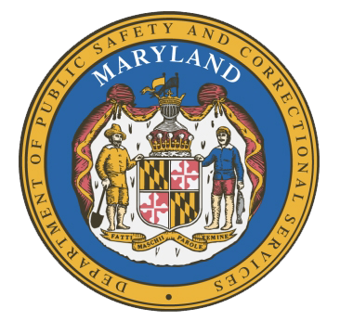
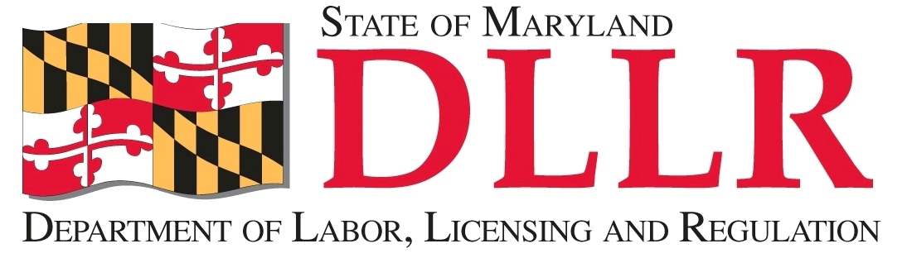
MARYLAND
Department of Public Safety and Correctional ServiceS
In
Partnership
With

Correctional Education Council
December 15, 2016
10:00 am – 12:00 pm
Department of Labor, Licensing and Regulation
1100 North Eutaw Street, Room 108
Baltimore, MD 21201

Council Meeting Agenda

Welcome/Review of Prior Meeting Minutes Secretary Stephen Moyer
Deputy Secretary David McGlone

DPSCS Updates Secretary Stephen Moyer

DLLR Updates Deputy Secretary David McGlone

Success Story of a Returning Citizen Antoine Payne

Diesel Program Edward Schwabeland, Kenneth Weeden, Tamara Barron, and Phil Holmes

Academic Curriculum Update Dr. Fran Tracy-Mumford

Correctional Education Updates Alice Wirth and Staff
- Staff Vacancies Dr. Jack Cunning
- Academic Updates Alice Wirth
- Occupational Updates Tamara Barron
- Transitional Updates Erica DuBose

Employer Advisory Committee Meeting Update Jack Weber

Meeting Dates for 2017 Alice Wirth

Concluding Remarks Secretary Stephen Moyer
Deputy Secretary David McGlone

